**Stage 5 – “Hallelujah! Holy s**t! Where's the Tylenol?”**

**RULES:** USPSA Competition Rules, Latest Edition **COURSE DESIGNER:** Ryan Christenson

|  |  |
| --- | --- |
| **START POSITION: See written stage briefing.** | |
| **STAGE PROCEDURE**  See written stage briefing. | **SCORING**  **SCORING:** Comstock 32 rounds.  **TARGETS:** 16 cardboard targets  **SCORED HITS:** 2 Best hits per carboard will be scored. Steel must fall to score.  **START-STOP:**  Audible - Last shot  **PENALTIES:** Per USPSA Competition Rules |

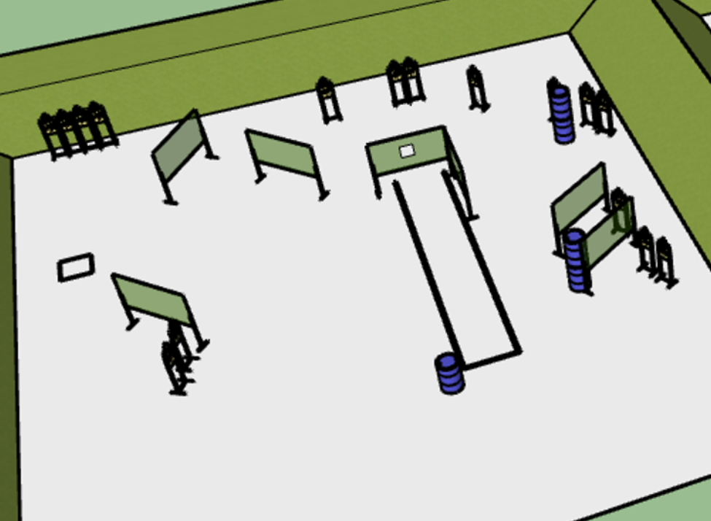

**Written Stage Briefing:**

**Stage 5 – “Hallelujah! Holy s**t! Where's the Tylenol?” –** is a 32-round, 160 point, Comstock Long Course. There are 16 cardboard targets. The best 2 hits per cardboard target will be scored.

**Start position**

Facing up range directly behind the barrel. Firearm is loaded and placed un-propped on barrel pointed directly down range.

On the audible start signal, engage targets from within the shooting area.

**Setup Notes:**

12 Single Wall Stands

1 Double Wall Stand

6 Full Walls

1 Port wall

16 Target stands / 32 target sticks

5+ barrels